**Tutorial 7: IP Addressing**

Q1 Identify the network portion and host portion for the following IP addresses based on the subnet mask given.

(i) 122.10.100.0/24 (201705 TAR UC, resit) (2 marks)

| **Network portion** | **Host portion** |
| --- | --- |
| 122.10.100 | .0 |

(ii) 180.80.0.0/16 (201705 TAR UC, resit) (2 marks)

| **Network portion** | **Host portion** |
| --- | --- |
| 180.80 | .0.0 |

Q2. Briefly describe each of the following in terms of Internet Protocol (IP) addresses.

(i) Network address (201705 TAR UC, resit) (2 marks)

* Network address is an identifier for a network/ the address by which we referred to the network
* Host portion of network address is all 0s (.00000000)

(ii) Host address (201705 TAR UC, resit) (2 marks)

* This address is assigned to any host of the interconnected network
* Host portion of the first host address is all 0s and ends with a 1 (.00000001)
* Host portion of the last host address is all 1s and ends with a 0 (.11111110)

(iii) Broadcast address (201705 TAR UC, resit) (2 marks)

* Broadcast address is used to communicate with other devices within the same local area network or subnet
* Host portion of broadcast address is all 1s (.11111111)

Q3. Based on Figure 1, answer the following questions:

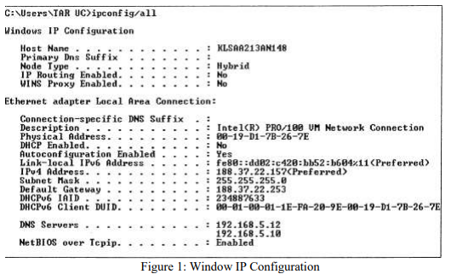

(i) What is the name of this computer? (201703 TAR UC, resit) (1 mark)

* KLSAA213AN148

(ii) Does this computer use static Internet Protocol (IP) version 4 address or dynamic IPv4 address? Explain your answer. (201703 TAR UC, resit) (3 marks)

* This computer is using static Internet Protocol (IP) version 4 address because the DHCP is not enabled

(iii) What is the Media Access Control (MAC) address of this computer? (201703 TAR UC, resit) (1 mark)

* 00-19-D1-7B-26-7E

(iv) If the user wants to send data to *188.37.20.120/24* by using this computer, which device and the device interface’s IP address should the computer send to? (201703 TAR UC, resit) (4 marks)

* Computer should send data to the default gateway (router) with the IP address (188.37.22.253)

Q4. Define “private address” and give ONE (1) example of private address blocks. (201505 TAR UC, resit) (3 marks)

* Private addresses are common blocks of addresses used by most organizations to assign IPv4 addresses to internal hosts.
* Private IPv4 addresses are not unique and can be used internally within any network (Not routable).
* E.G.
* 10.0.0.0 to 10.255.255.255 (10.0.0.0/8)
* 172.16.0.0 to 172.31.255.255 (172.16.0.0/12)
* 192.168.0.0 to 192.168.255.255 (192.168.0.0/16)

Q5. Outline the first octet range (decimal format) for Class A, B and C addresses. (201603 TAR UC, resit) (6 marks)

| **Class** | **Octet Range** |
| --- | --- |
| A | 1-127 |
| B | 128-191 |
| C | 192-223 |

Q6. Identify the address class and the default subnet mask of the following IP addresses.

(i) 192.168.10.10 (201705 TAR UC, resit) (2 marks)

| **Address class** | **Default subnet mask** |
| --- | --- |
| C | 255.255.255.0 |

(ii) 172.16.5.5 (201705 TAR UC, resit) (2 marks)

| **Address Class** | **Default Subnet Mask** |
| --- | --- |
| B | 255.255.0.0 |

(iii) 10.10.10.10 (201705 TAR UC, resit) (2 marks)

| **Address Class** | **Default Subnet Mask** |
| --- | --- |
| A | 255.0.0.0 |

Q7. Convert the IPv4 address of 209.165.200.228/30 into binary IPv4 address and binary subnet mask respectively. (201509 TAR UC, Main) (4 marks)

| **Binary IPv4 address** | 11010001 10100101 11001000 11100100 |
| --- | --- |
| **Binary subnet mask** | 11111111 11111111 11111111 11111100 |

Q8. Identify the class, default mask and network address for IPv4 address of 172.30.100.88. (201509 TAR UC, Main) (3 marks)

| **Class** | B |
| --- | --- |
| **Default mask** | 255.255.0.0 |
| **Network address** | 172.30.0.0 |

Q9. Describe how a router uses the addressing field in an IP header to determine where to forward a packet. (201409 TAR UC, Main) (6 marks)

* The IPv4 destination addressing field contains the destination IP address of the host
* The router uses the destination IP address and perform ANDing process to determine the network address
* Then, the router checks its routing table to determine where to forward the packet

Q10. Write the compressed format for each of the following in terms of IPv6 address.

(i) 2001:0DF8:C090:0511:0000:0000:0008:A0C0 (201705 TAR UC, resit) (2 marks)

* Rule 1: 2001:DF8:C090:511:0:0:8:A0C0
* Rule 2: 2001:DF8:C090:511::8:A0C0

(ii) 2001:00B3:0060:902A:0000:0000:AA:0000 (201705 TAR UC, resit) (2 marks)

* Rule 1: 2001:B3:60:902A:0:0:AA:0
* Rule 2: 2001:B3:60:902A::AA:0

Q11. With reference to Figure 2, answer the following questions. Write your answer in your answer booklet.

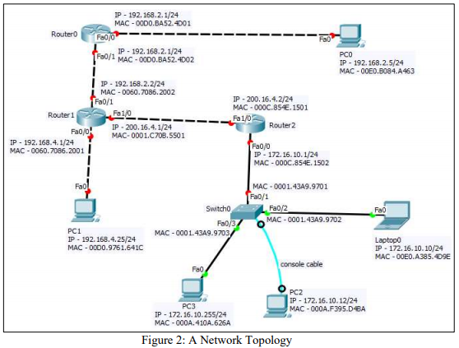

(i) How many networks shown in Figure 2? (201605 TAR UC, resit) (1 mark)

* 5 (from router to any device)

(ii) “PC0 and PC2 are in the same network.” Do you agree with this statement? Justify your answer. (201703 TAR UC, resit) (3 marks)

* I’m not agree with this statement. PC0 and PC2 is not in the same network
* Because network portion of PC0 and PC2 is not the same which not in the same network
* PC0 belongs to 192.168.2.0 while the PC2 is belongs to 172.16.10.0

(iii) Laptop0 is trying to ping PC2. What will be the expected result? Explain your answer. (201703 TAR UC, resit) (3 marks)

* The ping request time out because the cable that used to connect Laptop0 to PC2 is a console cable
* Console cable doesn’t provide network connectivity but only used to used to connect its terminal to the Switch0 console port to configure Switch0 through its terminal

(iv) Laptop0 is trying to ping PC3. What will be the expected result? Explain your answer. (201703 TAR UC, resit) (3 marks)

* The ping fails because PC3 is misconfigured with the broadcast address (172.16.10.255/24) as its IP address.
* Broadcast address cannot be used as PC’s IP address

Q12. Identify the address class and the default subnet mask of the following IP addresses. (201709 TAR UC main)

(i) 192.14.6.0 (2 marks)

| **Address Class** | **Default Subnet Mask** |
| --- | --- |
| C | 255.255.255.0 |

(ii) 126.6.150.0 (2 marks)

| **Address Class** | **Default Subnet Mask** |
| --- | --- |
| A | 255.0.0.0 |

Q13. Give the compressed format for each of the following IPv6 addresses. (201709 TAR UC main)

(i) 2345:0DB8:0000:6666:0000:0000:0000:0100 (2 marks)

* **Rule 1:** 2345:DB8:0:6666:0:0:0:100
* **Rule 2:** 2345:DB8:0:6666::100

(ii) 2345:0DB8:0350:2222:0F0A:0000:0000:0070 (2 marks)

* **Rule 1:** 2345:db8:350:2222:0:0:70
* **Rule 2:** 2345:DB8:350:2222:F0A::70

(iii) 2345:ACAD:0001:0010:0000:0000:0000:0000 (2 marks)

* **Rule 1:** 2345:ACAD:1:10::0:0:0:0
* **Rule 2:** 2345:ACAD:1:10::